# Math 1 Name_______________________________

# 5-3 Practice Date________

The midpoint of a segment is the point that divides the segment into two congruent pieces. The midpoint of the segment that joins points  is the point.

To find the midpoint of the segment joining, , average the two values and average the two  values.

Find the midpoint of the segment with the following endpoints:

Example 1.  and 

Answer:



Example 2. and 

Answer:





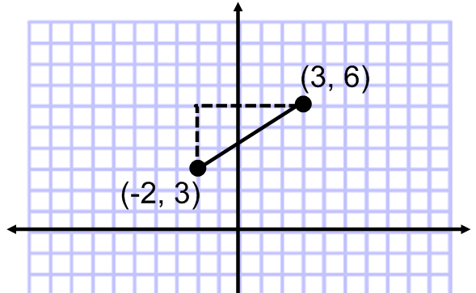The distance,, between two points with coordinates  can be found using the Pythagorean Theorem

Example 3. Find the distance between (-2, 3) and (3, 6).

Find the vertical distance between the y-coordinates.



Find the horizontal distance between the x-coordinates.



Use the Pythagorean Theorem () to solve for the distance.



Find the coordinates of the midpoint of the segment joining the given points.

1. (0, 2) and (6, 4)

2. (-11, 3) and (8,-7)

3. (2.3, 3.7) and (1.5, -2.9)

4. (*x*, 2) and (*x* + 4, -4)

Find the distance between the two points.

5. (-4, 2) and (2,-1)

6. (-2, -3) and (-2, 4)

7. (3, 2) and (5, -2)

8. (5, -7) and (8,-2)

For the given endpoints of a diameter in a circle, find

a. the center of the circle

b. the radius of the circle

9. (-8, 6) and (0, 0)

10. (4,-9) and (-2, -9)

11. The midpoint of two coordinates is (5, 7). If one coordinate is (8, 3), what is the other coordinate?

12. The midpoint of two coordinates is (-3, 2). If one coordinate is (4, 5), what is the other coordinate?

13. The distance between two coordinates is If the coordinates are (7, 3) and (15, *y*), what value(s) could *y* be?

14. The distance between two coordinates is If the coordinates are (2, 7) and (*x*, -3), what value(s) could *x* be?